
Data Flow Diagram
Date | 30 June 2026
Team ID
Project Name | Smart Lender
Maximum Marks | 2 Marks
Data Flow Diagram
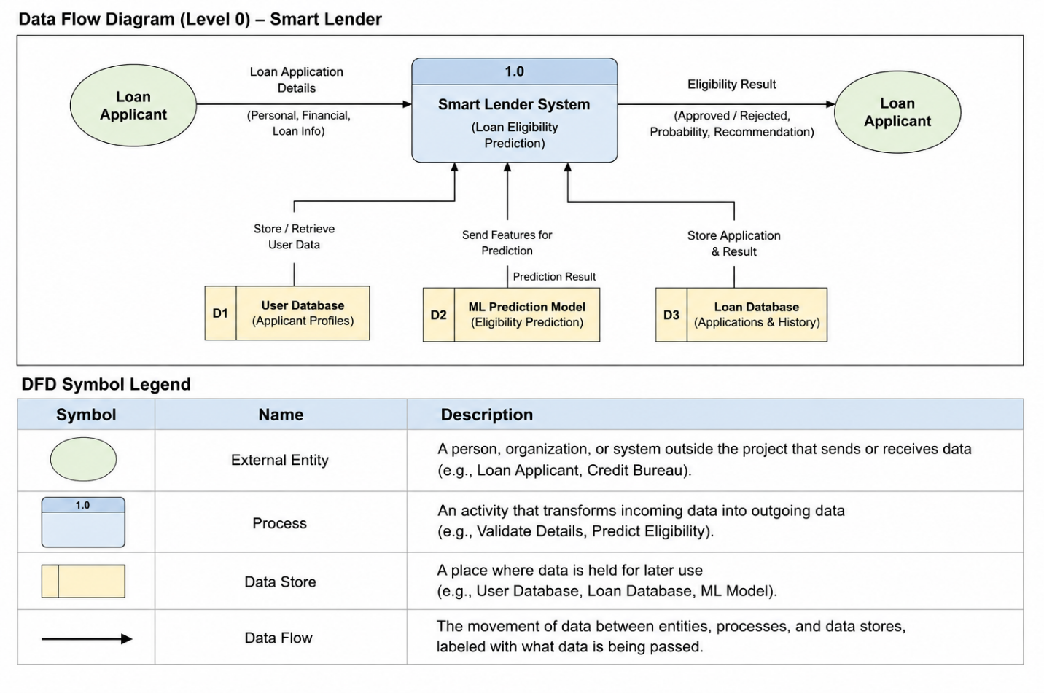

DFD Symbol Legend



Example

